**Singal and system**

**Lab 6**

NAME:- Aniket Roy

ROLL NO:- 19CS8020

REG NO:- 19U10064

**1. Find the Fourier transform of the following in symbolic form**

**a>**

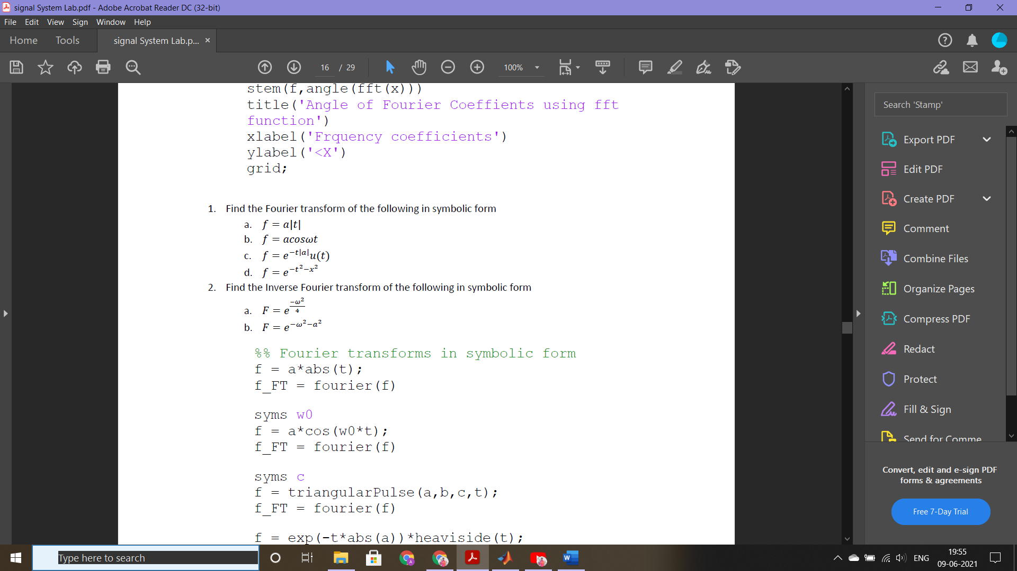

syms t a

f = a*abs(t);

fourier(f)

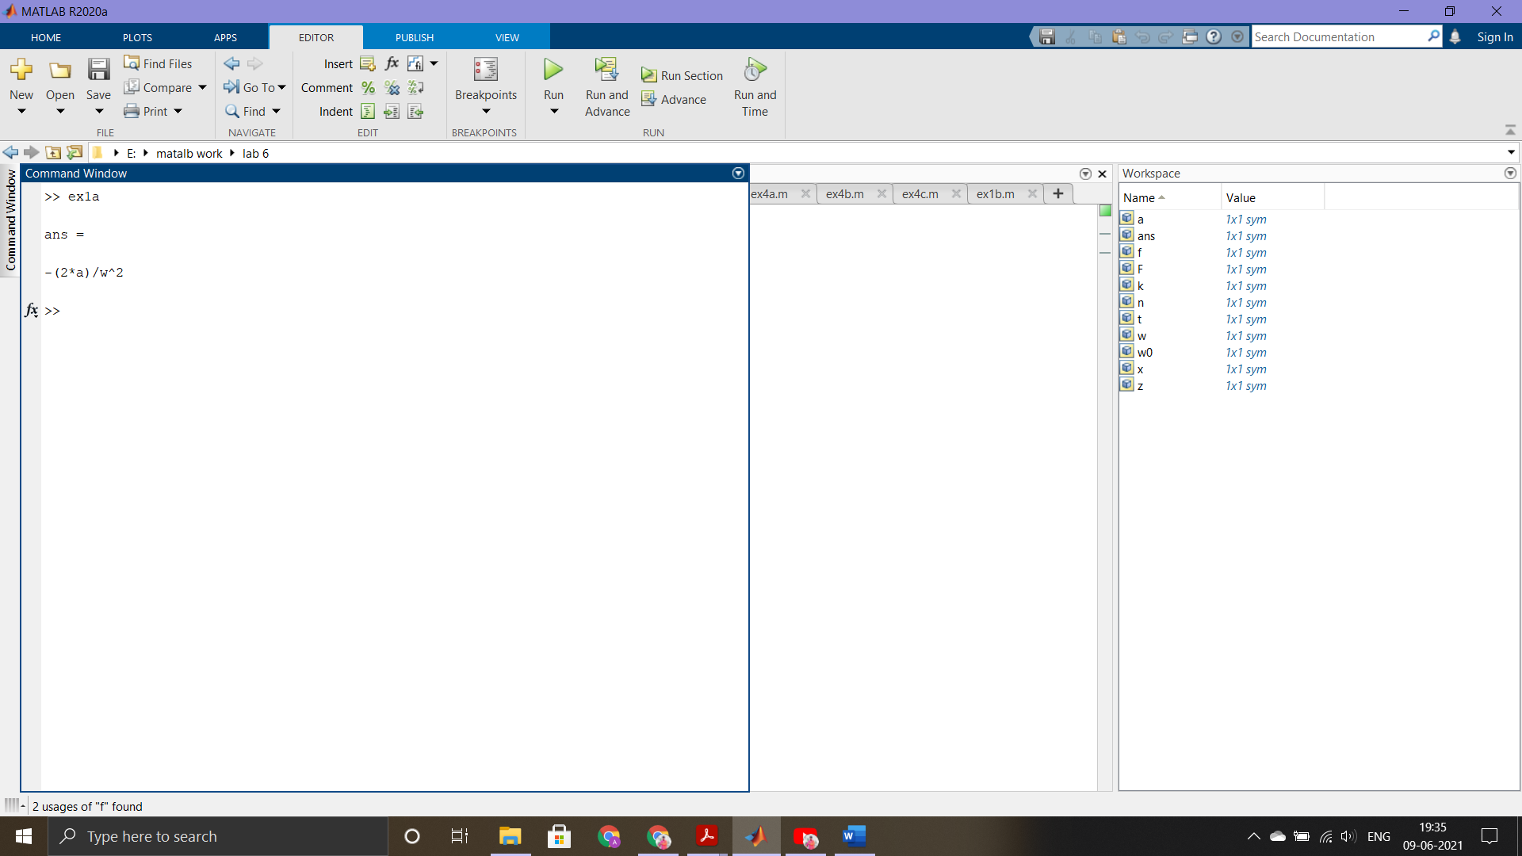

**b>**

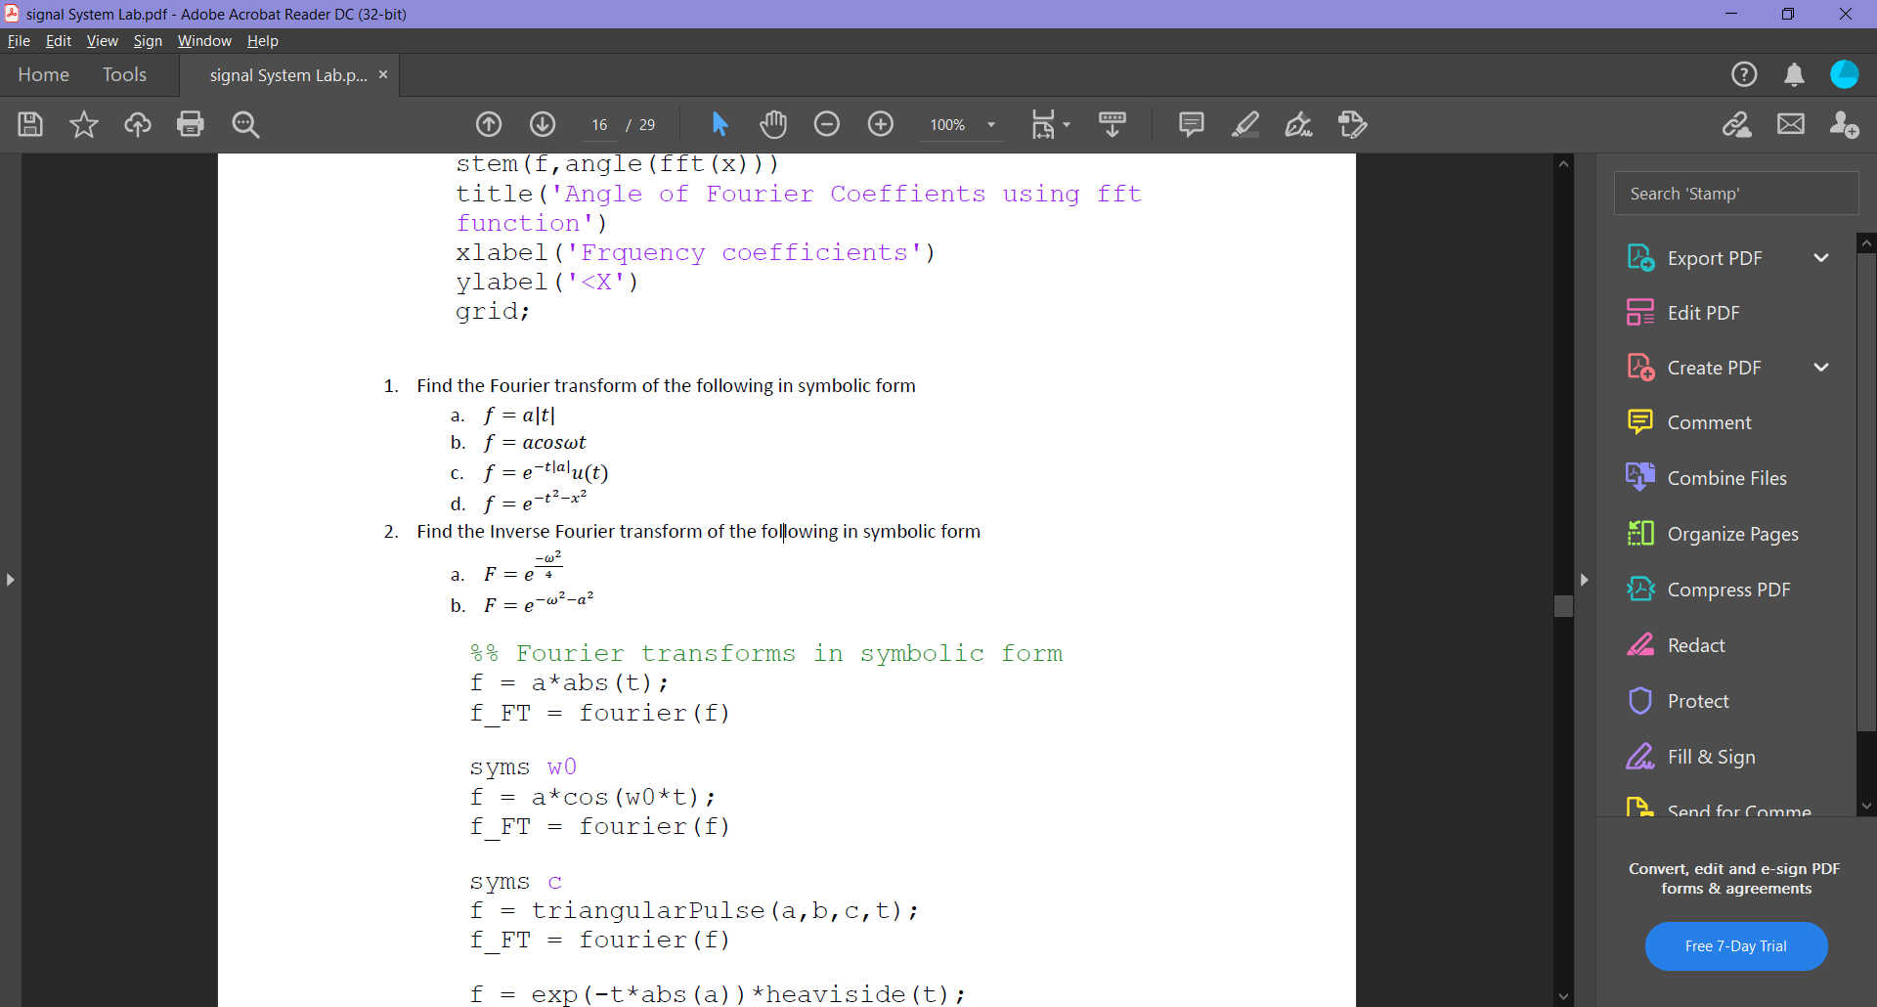

syms t a w0

f = a*cos(w0*t);

fourier(f)

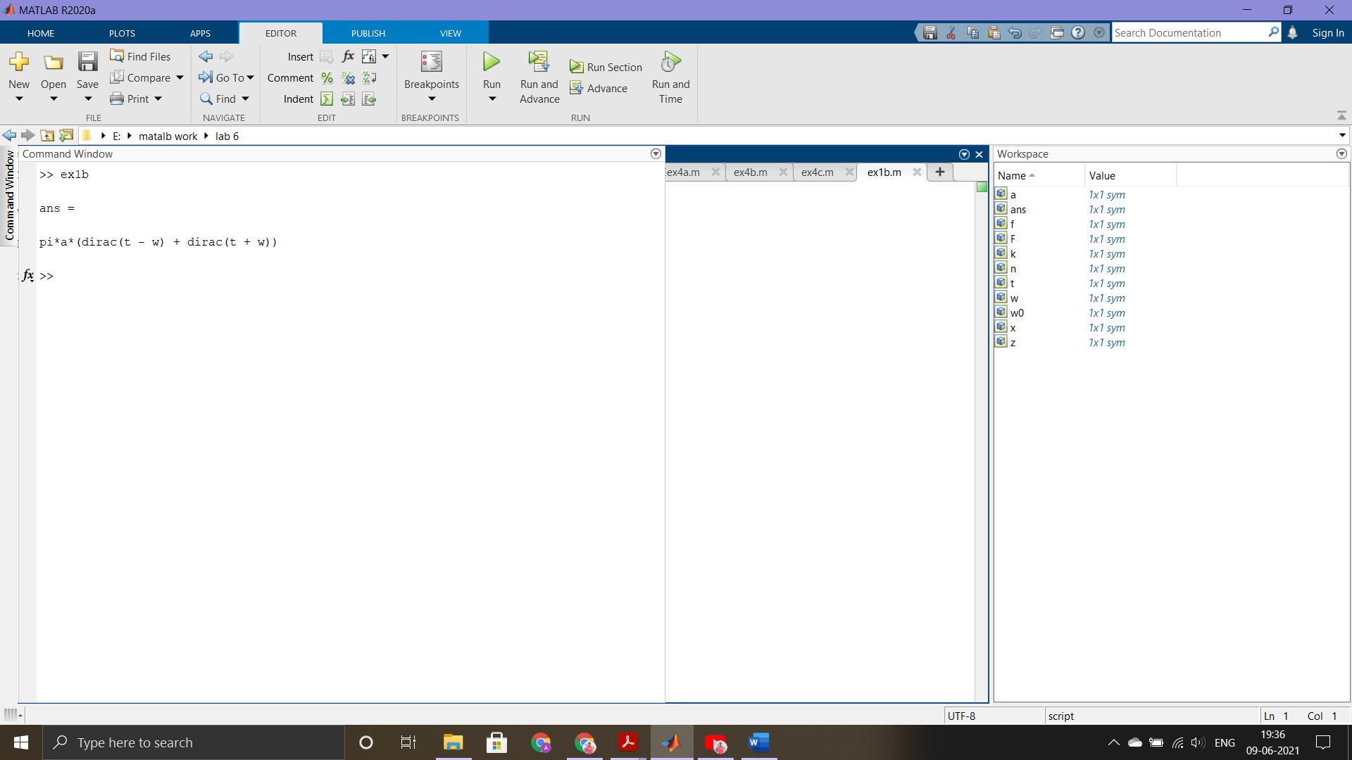

**c>**



syms t a

f = exp(-t*abs(a))*heaviside(t);

fourier(f)

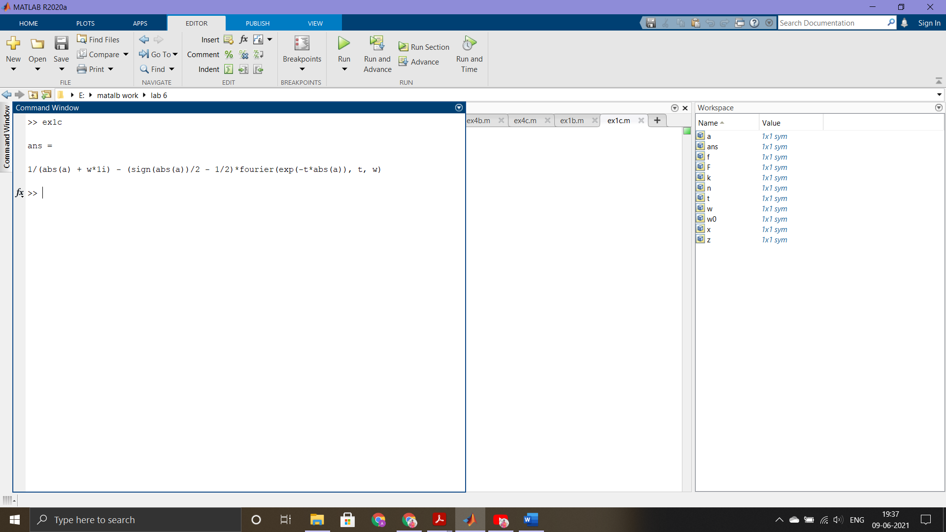

**d>**



syms t x

f = exp(-t^2-x^2);

fourier(f)

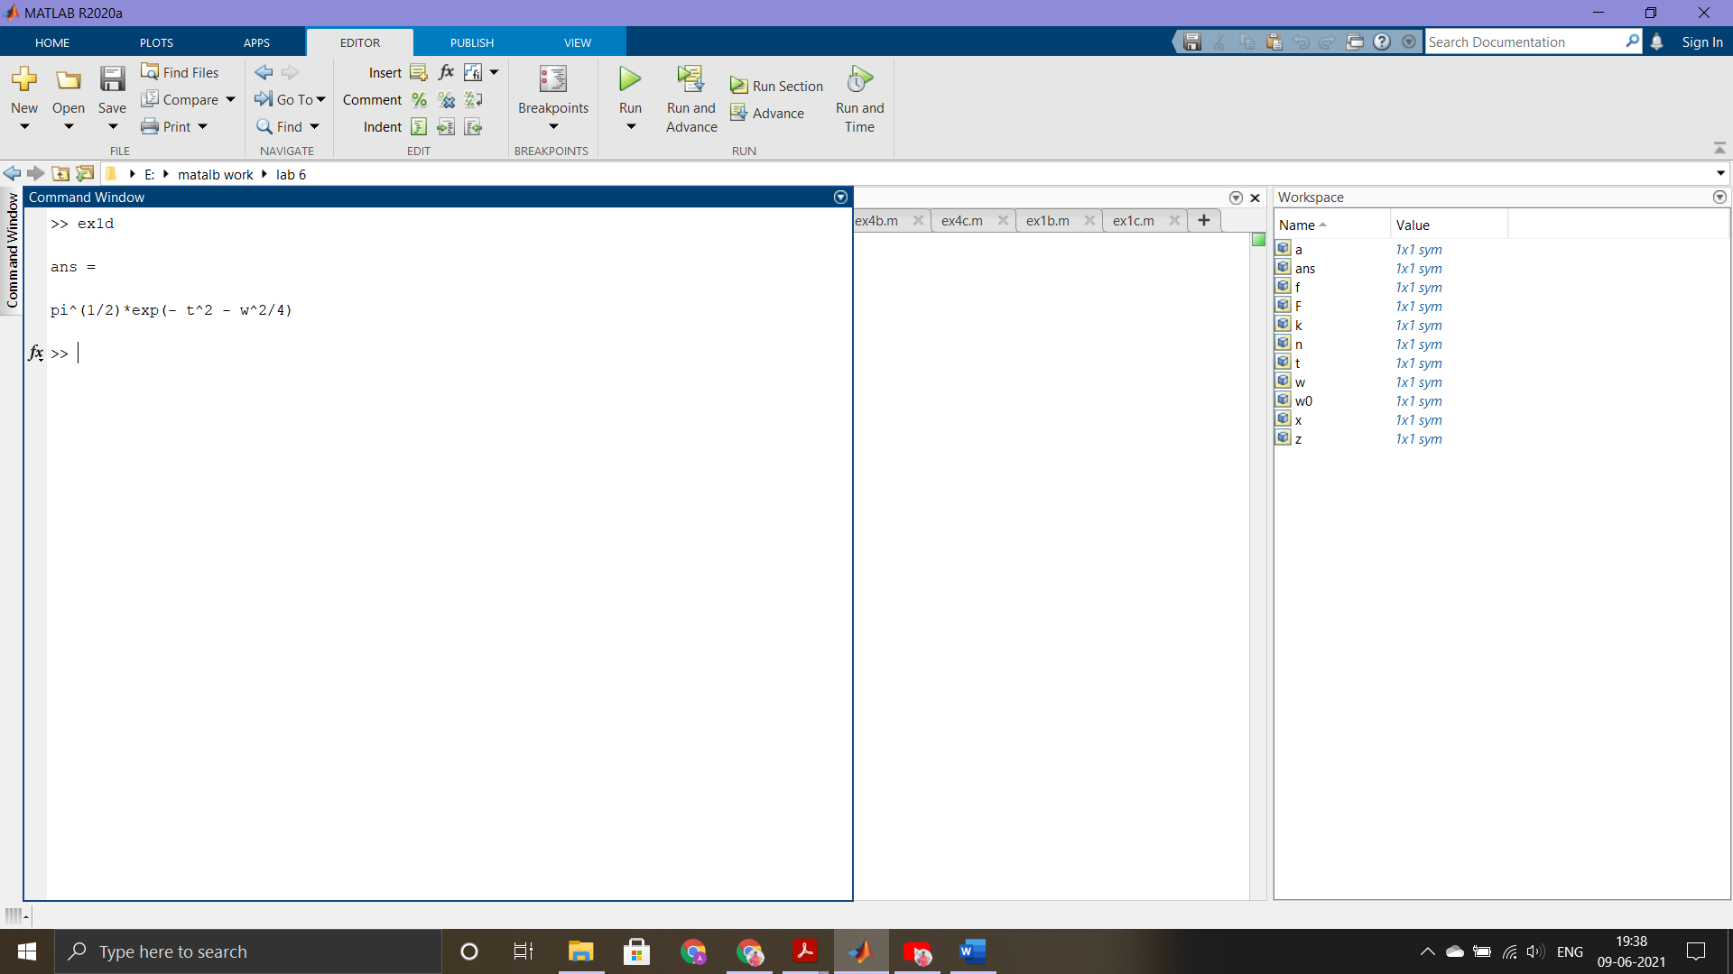

**2. Find the Inverse Fourier transform of the following in symbolic form**

**a>**



syms w

F = exp(-w^2/4);

ifourier(F)

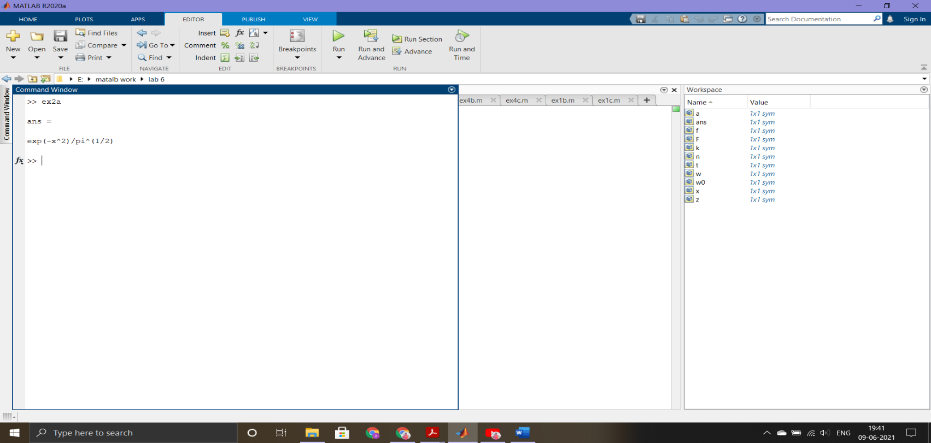

**b>**



syms a w t

F = exp(-w^2-a^2);

ifourier(F)

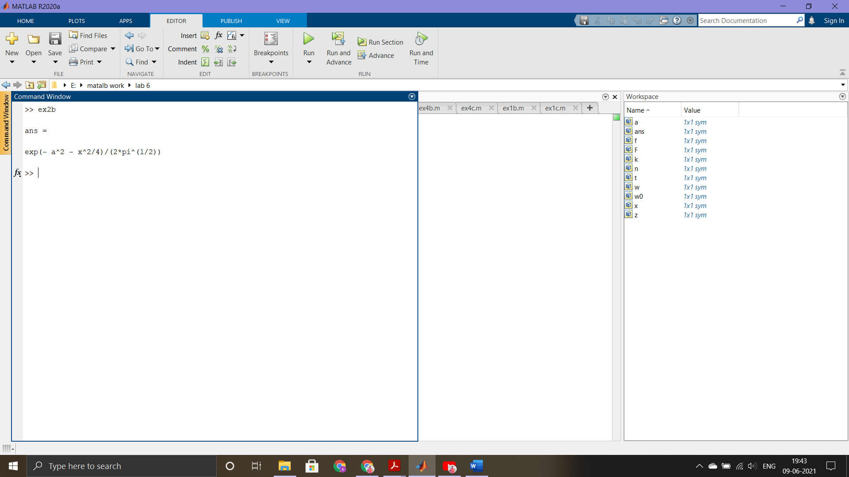

**3. Find the Z- transform of the following in symbolic form**

**a>**

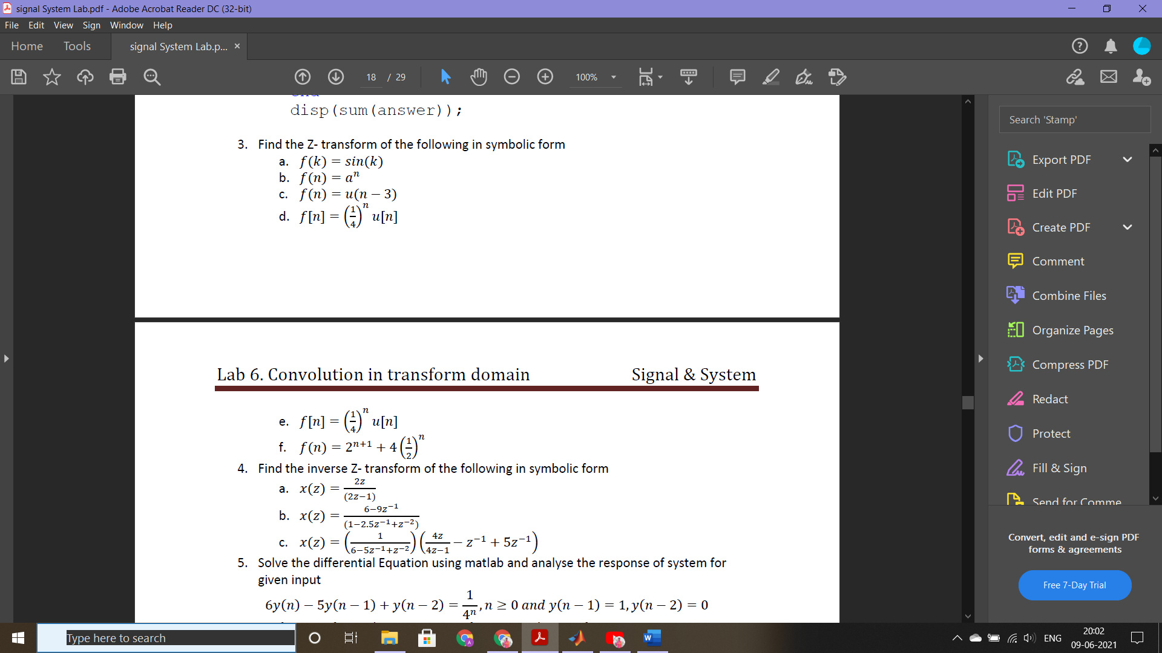

syms k x

f = sin(k);

ztrans(f, k, x)

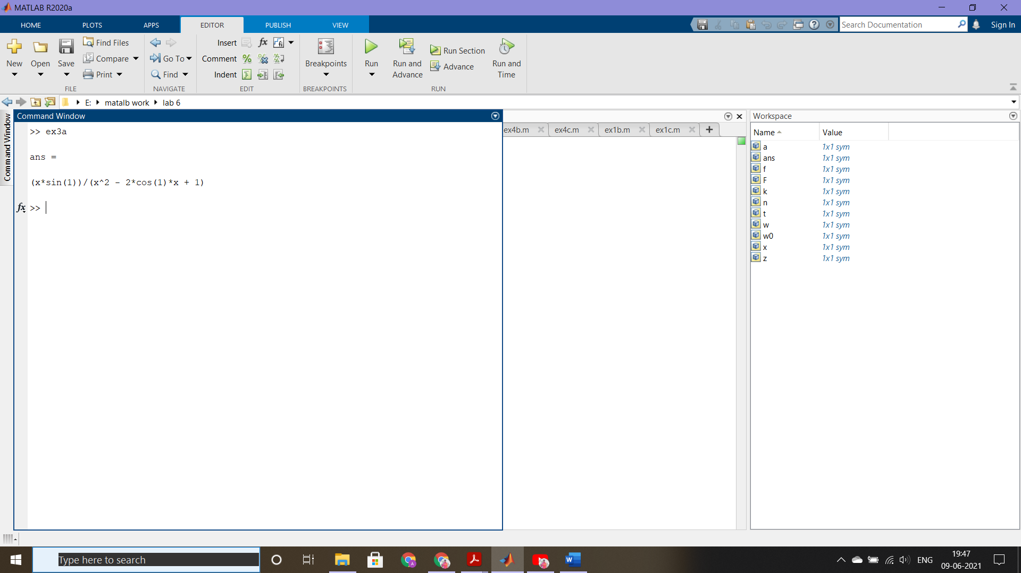

**b>**



syms a n x

f = a^n;

ztrans(f, x)

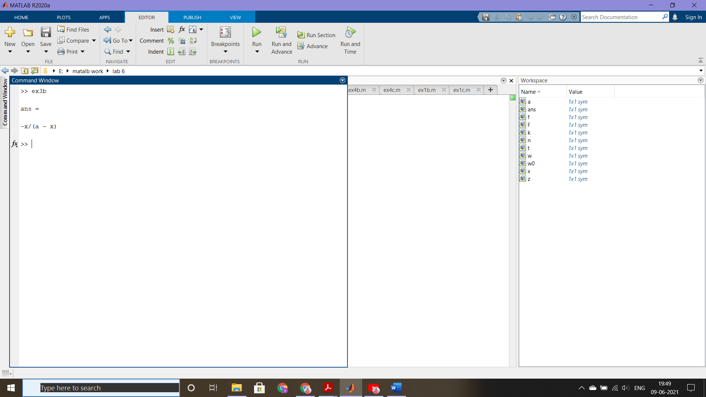

**c>**



syms n z

ztrans(heaviside(n - 3), n, z)

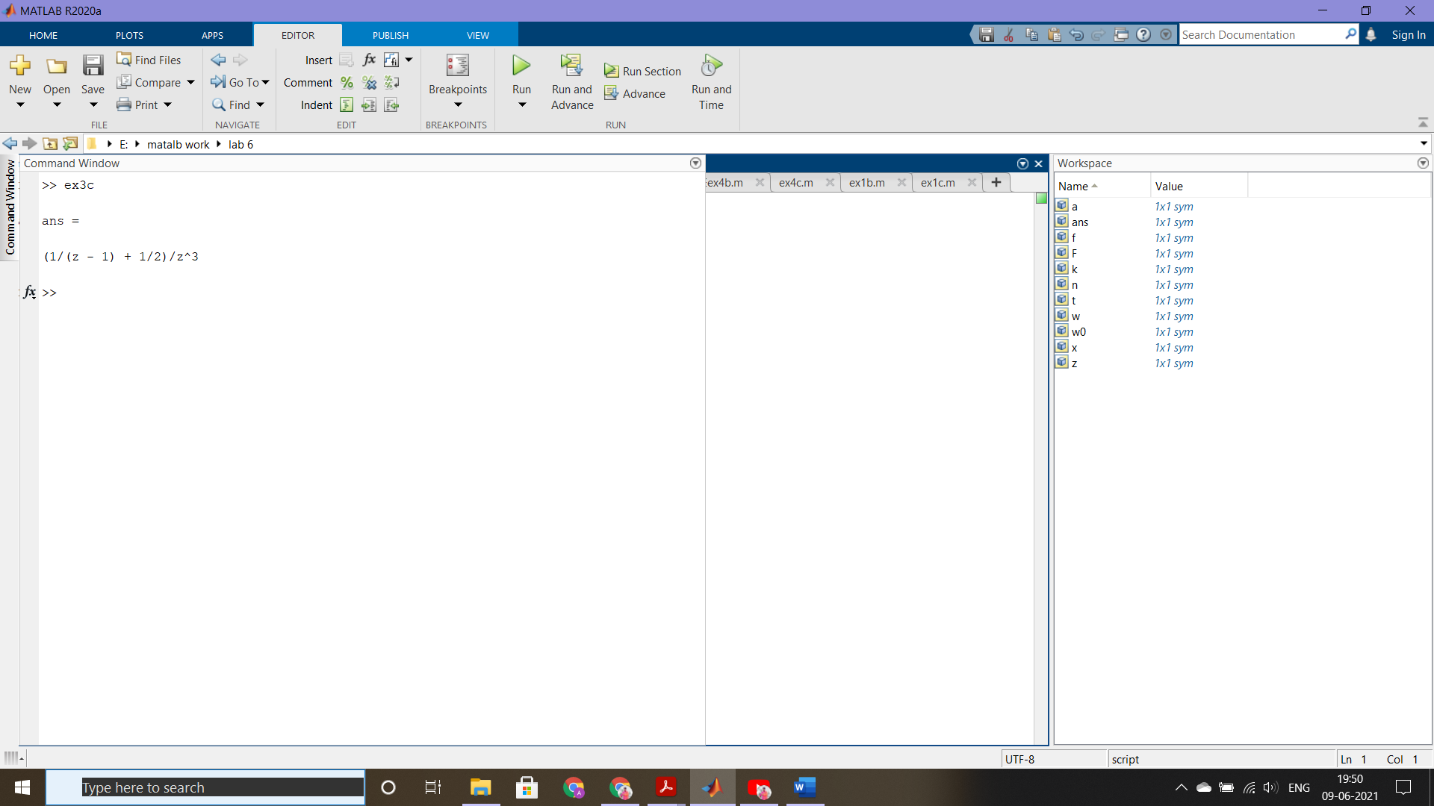

**d>**



syms z n;

ztrans(1/4^n)

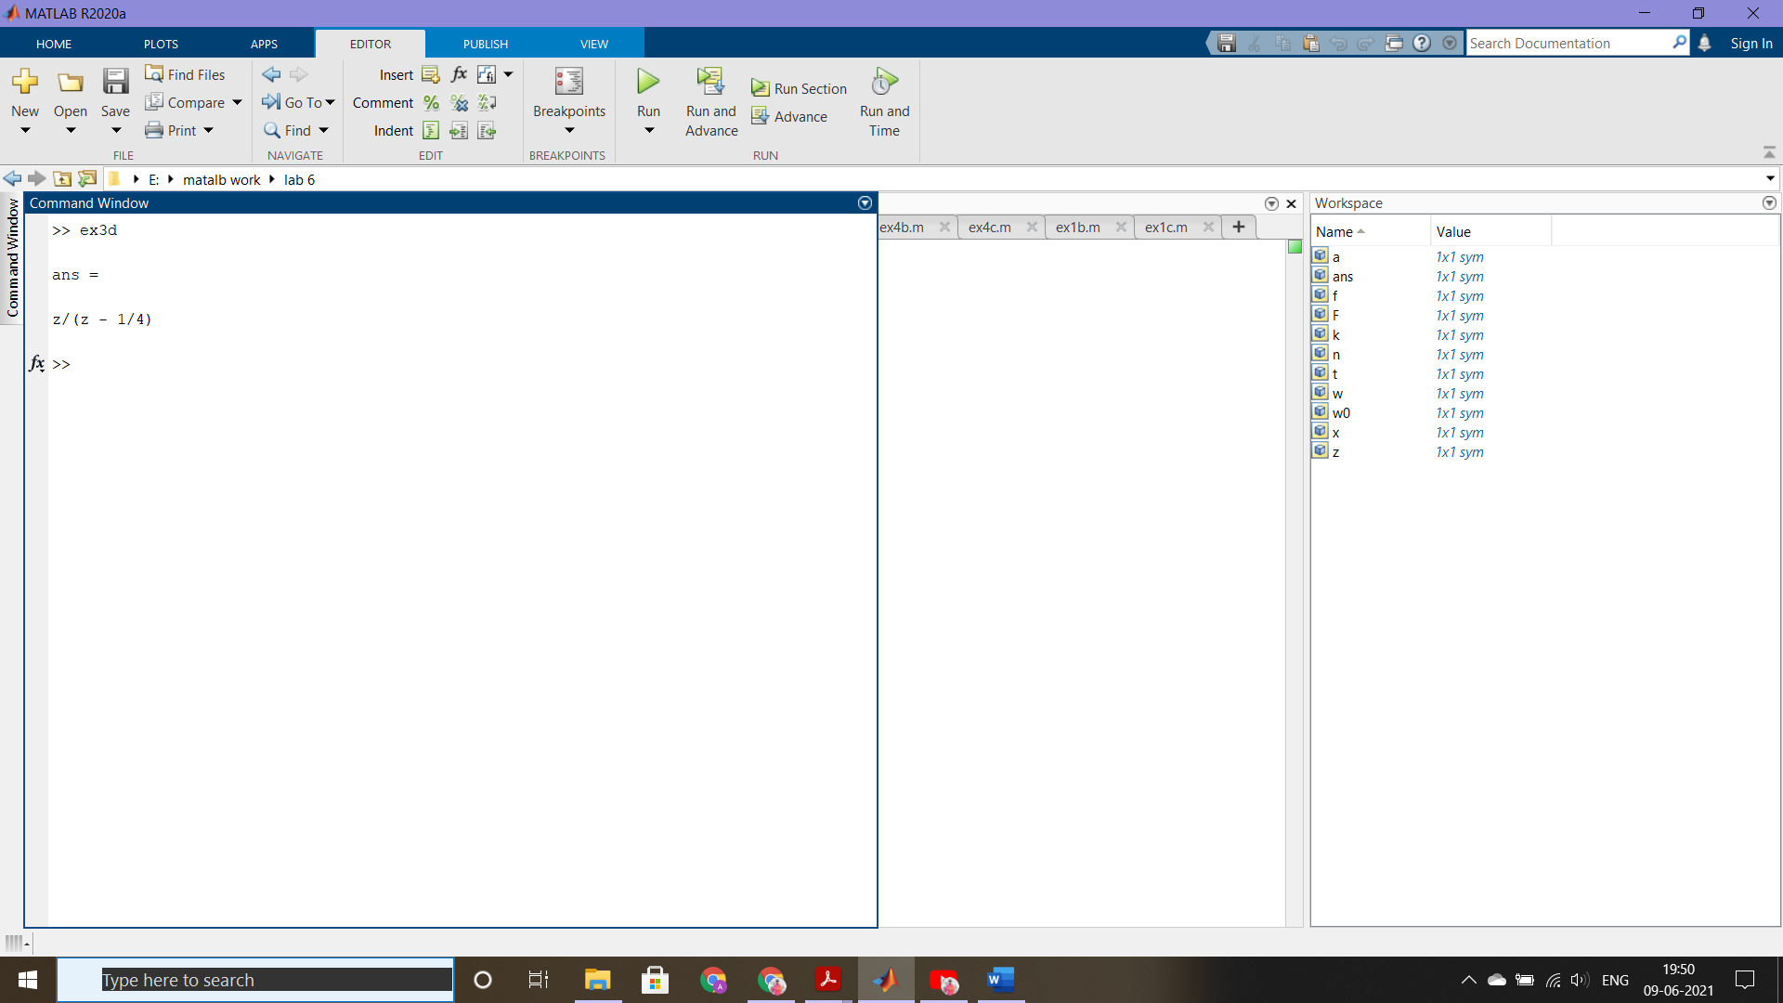

**f>**



syms z n

ztrans(2*2^n+4*(1/2)^n)

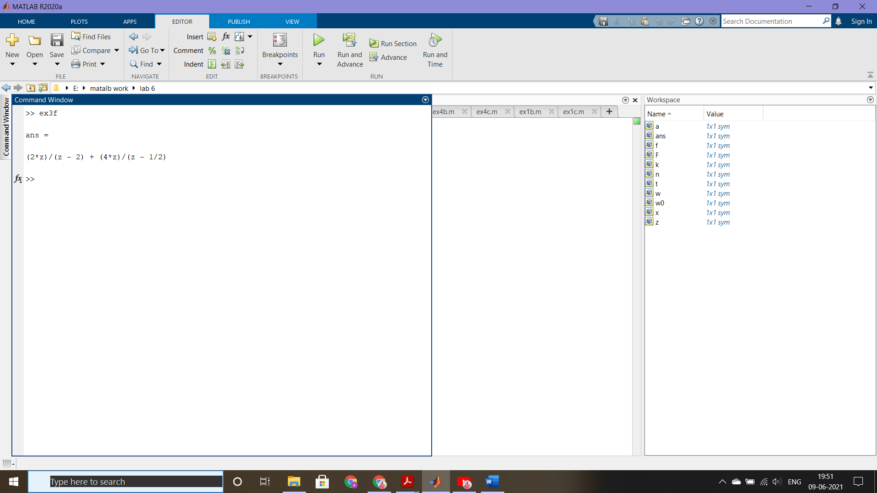

**4. Find the inverse Z- transform of the following in symbolic form**

**a>**

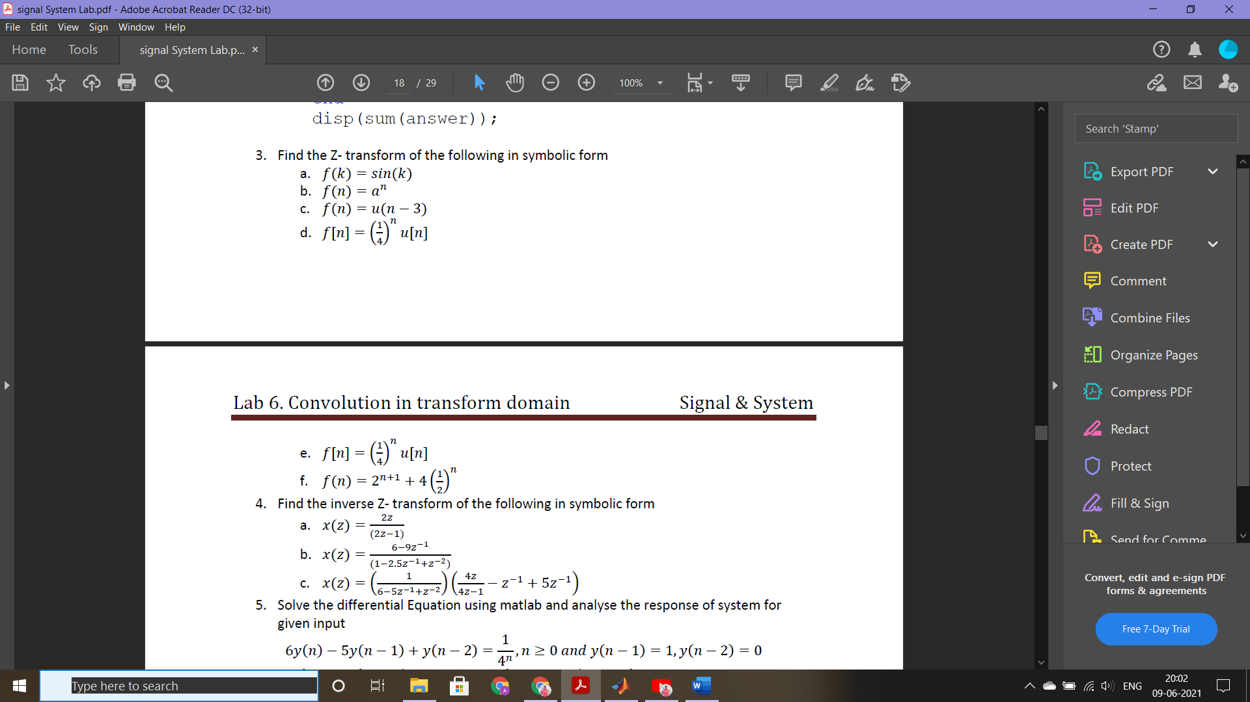

syms z n;

iztrans(2*z/(2*z-1))

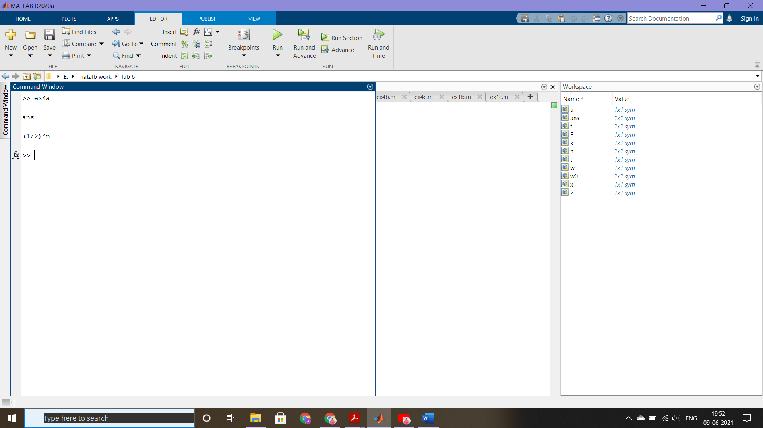

**b>**



syms z n;

iztrans((6-9*z^-1)/(1-2.5*z^-1+z^-2))

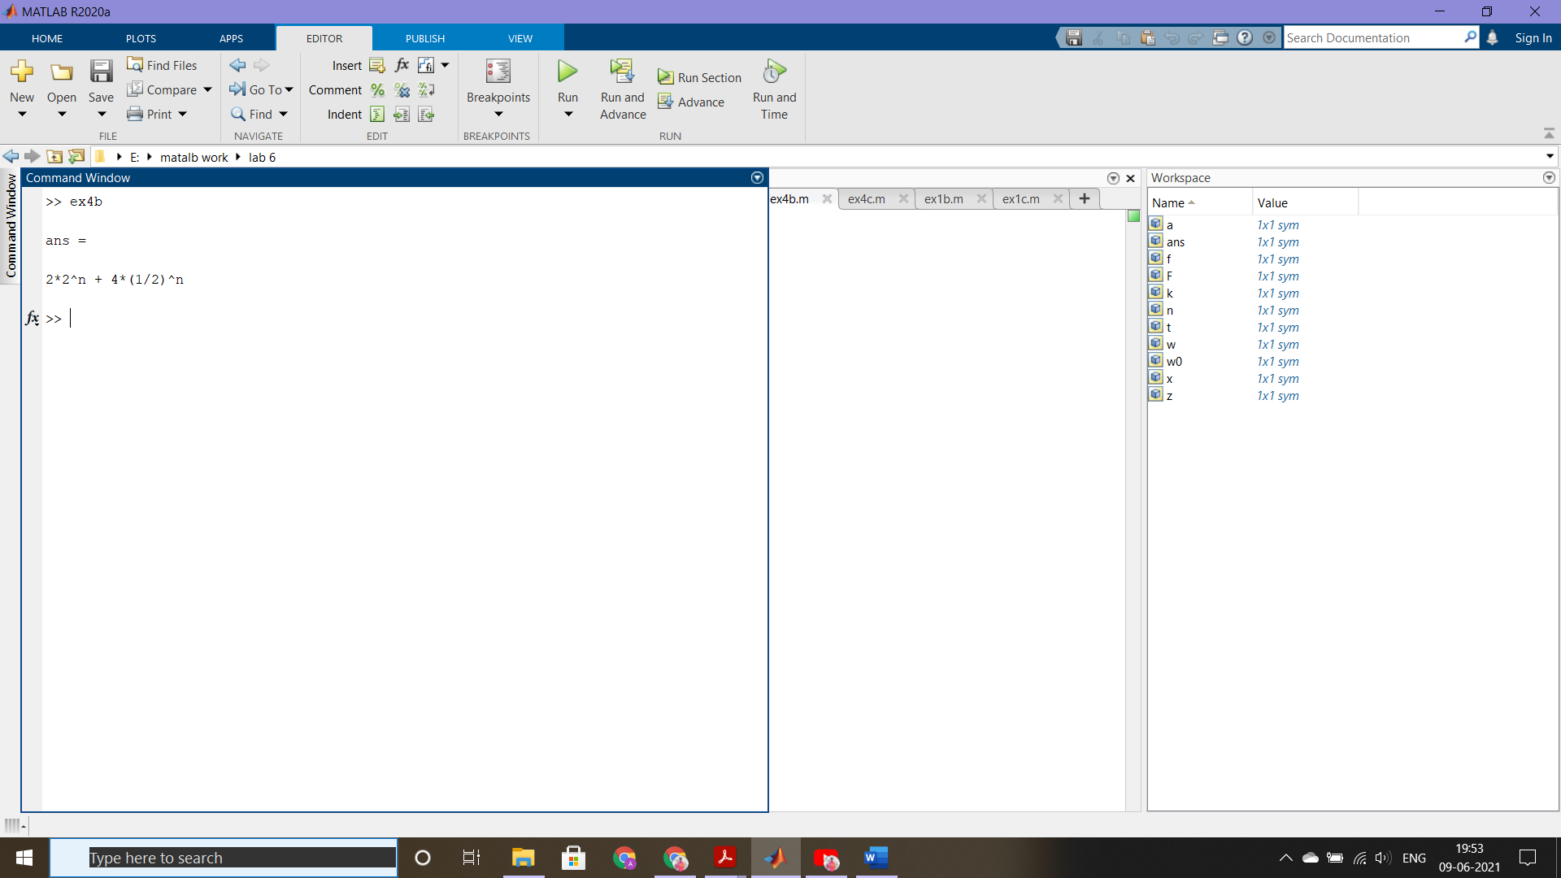

**c>**



syms z n;

iztrans((1/(6-5*z^-1+z^-2))*((4*z/(4*z-1))-z^-1+5*z^-1))

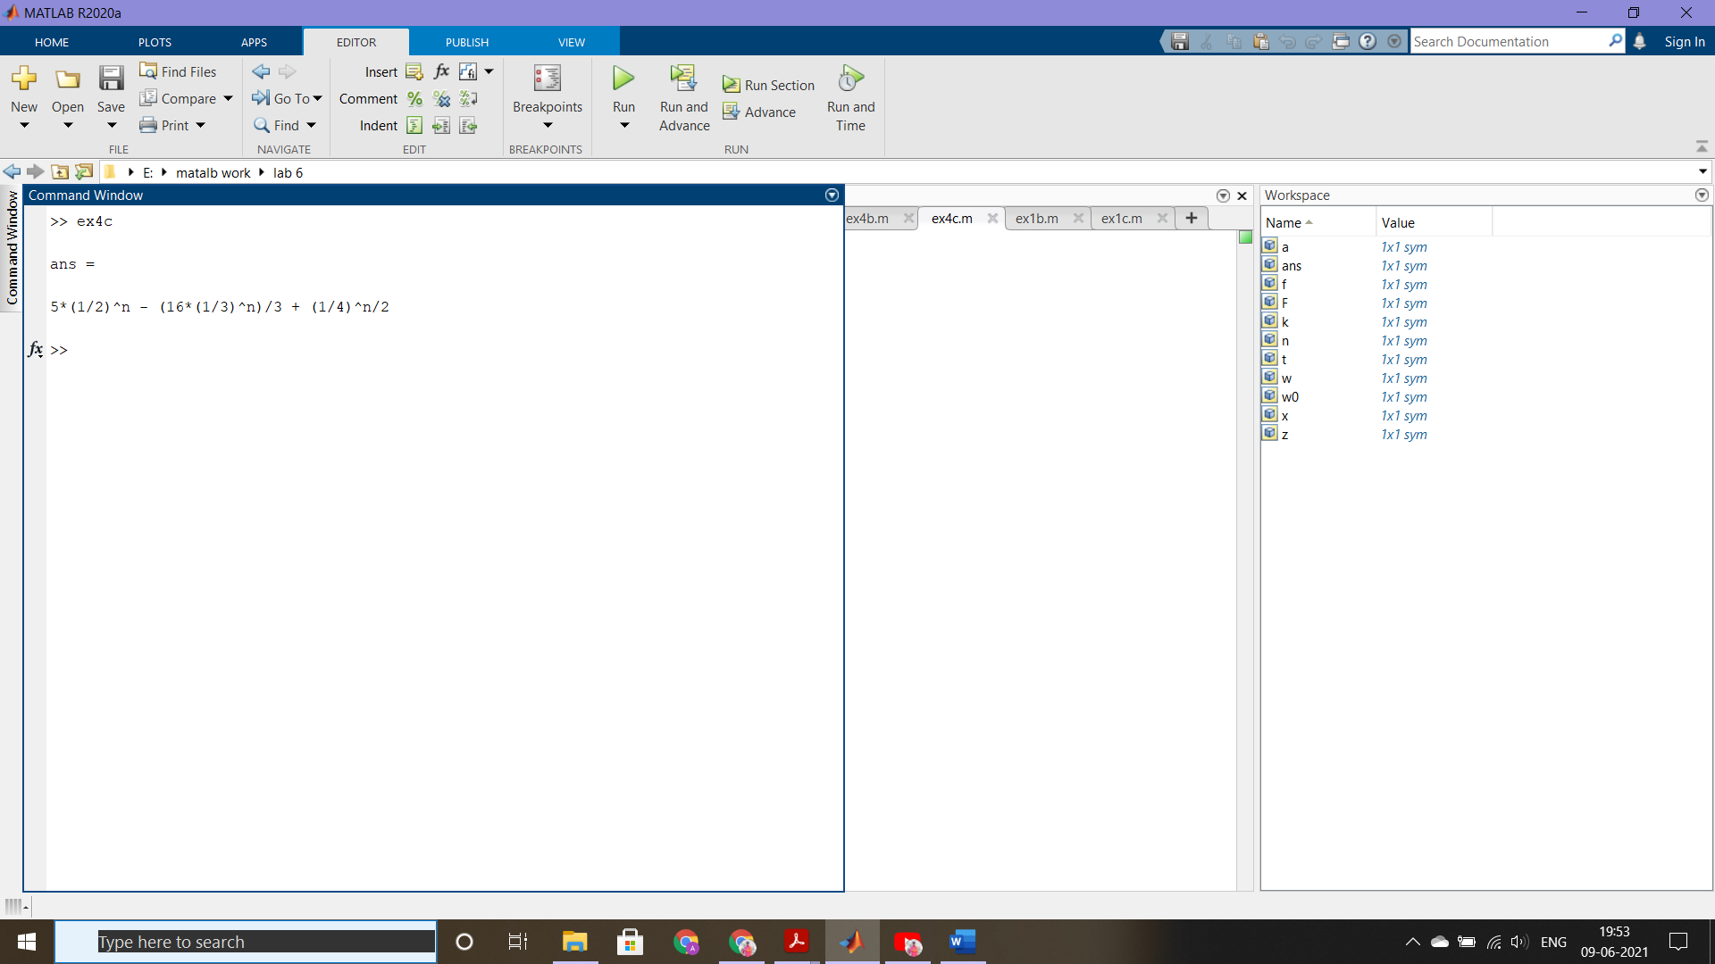

**6. verification of convolution property of Fourier and Z-transform**

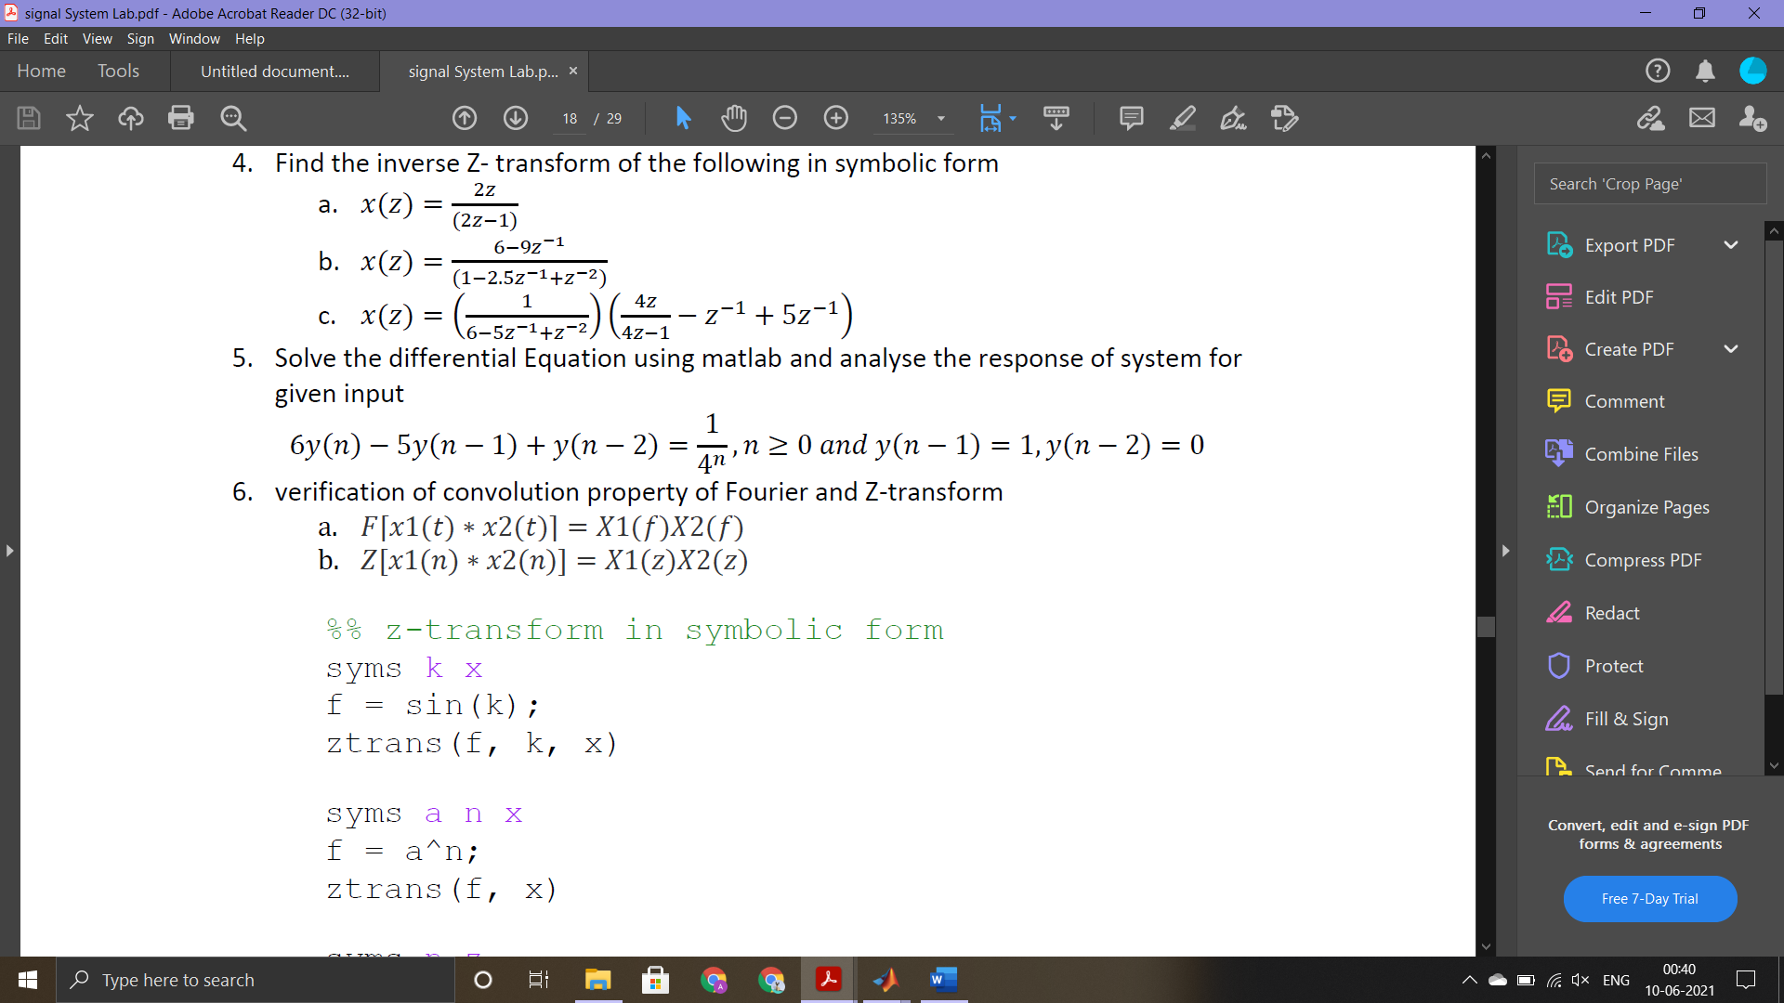

function [ w ] = convmat(x1,x2)

n=0:100;

x1=[1 2 3 4 5];

x2=[6 7 8 9 10];

lengthofx1=length(x1);

lengthofx2=length(x2);

X1=[x1,zeros(1,lengthofx2)];

X2=[x2,zeros(1,lengthofx1)];

for k=1:(lengthofx1+lengthofx2-1)

w(k)=0;

for j=1:lengthofx1

if(k-j+1)>0

w(k)=w(k)+X1(j)*X2(k-j+1);

end

end

end

subplot(2,4,2)

r=x1.*x2;

f=abs(fft(r));

stem(f)

title('fourier transform of two multiplied signals')

subplot(2,4,6)

a1=abs(fft(x1));

a2=abs(fft(x2));

b=conv(a1,a2);

stem(b)

title('convolution of two fourier transformed signals')

end

